Git Common Merge types and Strategies

- The Fast Forward Merge Strategy

A fast forward merge occurs when the target branch has not diverged from the source branch. Git simply moves the target branch pointer to the latest commit in the source branch. This approach keeps the commit history linear and clear.

- Creates a linear commit history with no merge commit.
- Used when the main branch has no new commits.
- Moves the branch pointer forward.
- Keeps the project history clean and straight.
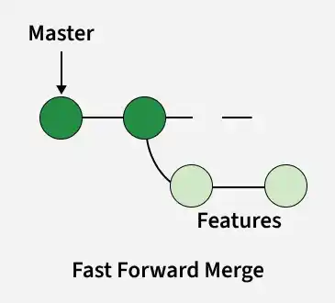

- Recursive Merge Strategy

Recursive merge is Git’s default strategy for merging diverged branches. It creates a merge commit that combines changes while preserving the history of both branches.

- Used when both branches have new commits since they diverged.
- Git creates a new merge commit with two parent commits.
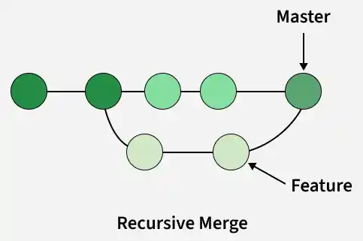

- Octopus Merge Strategy
Octopus merge is used for merging more than two branches simultaneously. It’s less common and typically used for automated merges involving multiple feature branches.
- Used to merge more than two branches at once.
- Avoids complex merges that require manual conflict resolution.
- Commonly used to combine multiple topic branches.
- Default strategy when merging or pulling multiple branches.

